Tuesday 26 November 2024

Venue: Community Centre Walkershaugh Peebles EH45 8AU

**Judge: Alan Riach**.

ALL ENTRIES SHOULD BE AT THE HALL **BY 7.00 pm**, JUDGING STARTS **7.30 pm**

**Honey Show Rules**

1. Entries for the show are open to paid-up members of the Peeblesshire Beekeepers Association (PBKA). Membership info - [peeblesbeekeepers.org.uk/?page_id=1591](http://peeblesbeekeepers.org.uk/?page_id=1591)

2. Exhibits must be the property of, and be prepared solely by, the exhibitor.

3. All honey and wax must be the *bona fide* produce of the exhibitor’s bees.

4. Only one entry per class is allowed.

5. Exhibitors may enter as many different classes as they wish.

6. Prize tickets will be awarded to first, second & third entries in each class.

7. Cut comb honey must be shown in white or clear cut comb cases with clear lids.

8. Comb honey sections must be enclosed in commercial sale section cases or have clear covers on both sides.

9. Extracted honey must be exhibited in plain, unmarked, clear 454g squat jars (glass or plastic) with gold lacquered metal, or gold or white plastic, screw top or twist off lids.

10. Frames must be shown in a protective case where the comb is visible from both sides.*

11. Mead must be shown in unmarked, punted, clear glass bottles with rounded shoulders of approx. 75ml capacity, sealed with a plastic top flanged cork.

12. Recipes where shown must be adhered to.

13. Entrants in the novice classes (14 - 15) must never have previously exhibited at the PBKA Honey Show.

14. The Judge may withhold prizes in case of insufficient merit.

15. The Judge’s decision is final.

**TROPHIES**

The **John Stoakley Memorial Cup** will be awarded to the winner of most points in honey classes.

The **Andrew Stewart Memorial Shield** will be awarded to the beekeeper with 6 or fewer hives, with the most points in classes 1 - 15.

Points calculated on the following basis

First – 3 points, Second – 2 points, Third – 1 point

In the event of a tie, the exhibitor having the most first prizes will be the winner.

The winners shall hold the trophies for one year and return these to the Secretary before the following year’s show.

* PBKA has 2 or 3 display cases that can be borrowed: book with Secretary in advance!

OPEN CLASSES

1. Two matching 454g (1lb) jars of light liquid honey.
2. Two matching 454g (1lb) jars of medium liquid honey.
3. Two matching 454g (1lb) jars of dark liquid honey.
4. Two matching 454g (1lb) jars soft set blossom honey.
5. Two matching 454g (1lb) jars ling heather honey.
6. Two matching 454g (1lb) jars ling heather blend honey.
7. One shallow (super) frame of honey (any variety).
8. Two matching comb honey sections/rounds (any variety).
9. Two matching containers of cut comb (any variety) not less than 200g (7oz).
10. One piece beeswax, weight not less than 225g (½ lb).
11. Three Matching Beeswax Candles.
12. One bottle of mead, volume not less than 70ml.

NOVICE CLASSES

13. One piece cut comb honey (minimum weight 200g).

1. One 454g (1lb) jar of honey any variety.

ADDITIONAL CLASSES

15. Photograph 6” x 4” unmounted print on a bee related theme.

1. Honey cake: to be displayed on a clean white paper plate and enclosed within a clear plastic wrapping. Recipe below.

Honey cake Recipe:

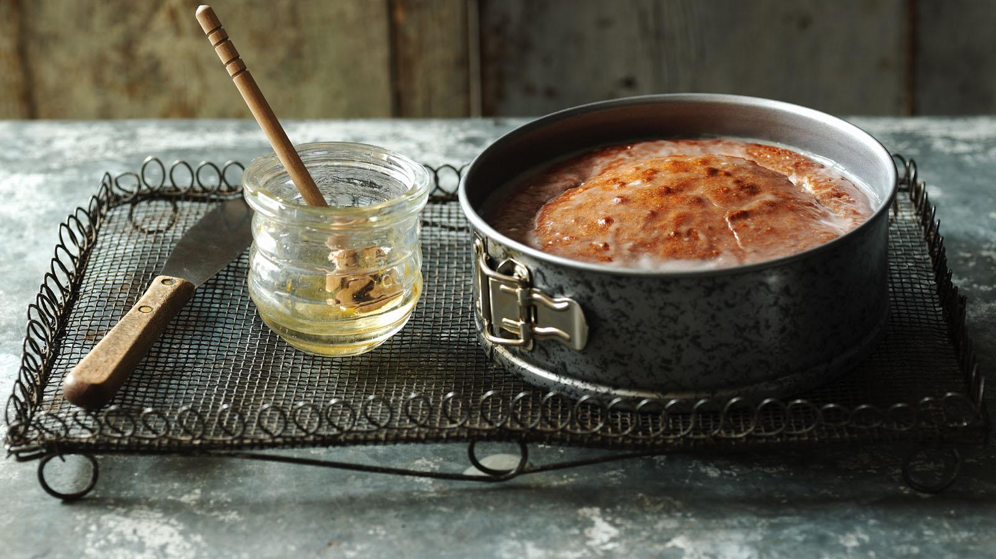

## Ingredients

* 170g/6oz clear honey
* 140g/5oz butter
* 85g/3oz light muscovado sugar
* 2 eggs, beaten
* 200g/7oz self raising flour, sieved
* water

### For the icing

* 55g/2oz icing sugar
* 1 tbsp clear honey
* hot water

## Method

1. Preheat oven to 180C/350F/Gas 3 and butter and line the bottom of a 7in/18cm cake tin.
2. Measure the honey, butter and sugar into a large pan. Add a tablespoon of water and heat gently until melted.
3. Remove from the heat and mix in the eggs and flour.
4. Spoon into the cake tin and bake for 40-45 minutes until the cake is springy to the touch and shrinking slightly from the sides of the tin.
5. Cool slightly in the tin before turning out onto a wire rack.
6. While the cake is still warm, make the icing by mixing the sugar and honey together with 2-3 teaspoons of hot water. Trickle over the cake in whatever design takes your fancy.

[www.bbc.co.uk/food/recipes/honeycake_67599](https://www.bbc.co.uk/food/recipes/honeycake_67599)